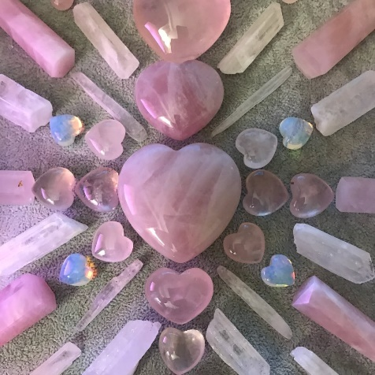
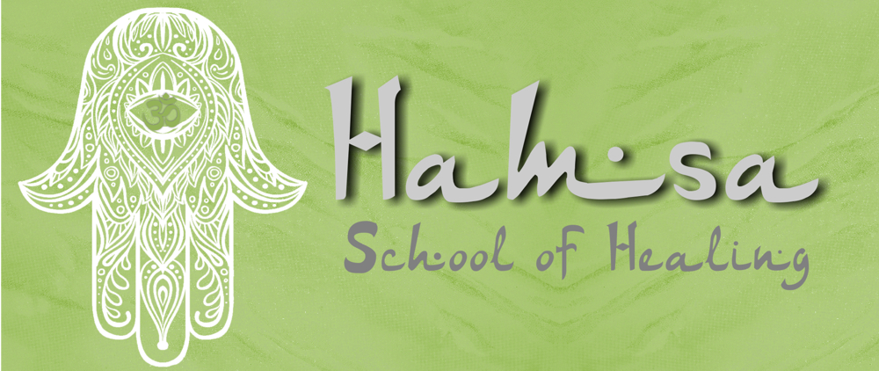

Timothy Van Minnen

Cape Town South Africa

https://hamsaschoolofhealing-uk.weebly.com/crystals-for-beginners.html

Crystals Healing for beginners
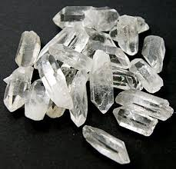
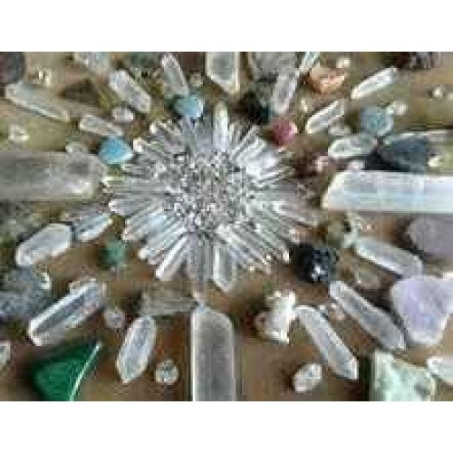
​What are crystals?
Crystals are minerals formed underground from three-dimensional repeating patterns of atoms. A crystal's appearance depends upon the natural characteristics of its type and the conditions in which it grows. Some take on strange shapes, some are very small and others grow very large, developing over thousands of years.
Programming and cleansing crystals
The repeating chemical structure of crystals is said to invest them with a kind of memory. This means that crystals have the power to hold energies. You may hold a quartz crystal with the intention of filling it with your love. This is what is meant by programming a crystal. You do not need any wires or a special connection with God - all you need is intention and focus. The crystal will remember your love, which will then permeate any environment in which the crystal is placed. Crystals can remember negative as well as positive energies and so will sometimes need to be cleansed. For instance, an amethyst will actually help to cleanse a room of negative energies (eg. anger) but this means that the amethyst, which will retain an element of that negative energy, will itself occasionally require cleansing.
There are various ways of cleansing crystals. One of the most common is to submerge them in salt water (sea water is excellent) for a couple of days, then run them under the tap to clean off the salt. Other methods include burying crystals in the garden for a few days, leaving them for a while in a stream (pick a slow-running one, or they may no longer be there when you come back for them!) or leaving them outside overnight in normal water to bask in the moonlight.
What gives individual stones their characteristics?
Different stones have different energetic properties. For example, a Tigers Eye can aid those seeking clarity, while Lapis Lazuli is said to expand our awareness and help us attune to our intuition. Rose Quartz is calming and sometimes referred to as the stone of gentle love. Many of the books available contain lists of crystals and what each one means. These meanings are simply interpretations of the energy each crystal carries. Some may consider a crystal with a fresh, lively, citrus feel to it to give zest and promote optimism, and therefore help to reduce depression.
With a little practise and intuition, anyone can interpret the immediate characteristics of a stone. For example, red is the colour of action, and red stones can invigorate and enliven in the same way that the blood in your body gives you life. White or clear stones such as quartz may help you to see more clearly. Purple stones may assist in transformation and change. By all means read and digest the definitions in books but realise that it is important to form your own opinions. The shape of a crystal may also affect its qualities. Some people will also consider the number of facets and, using numerology, which attributes meanings to different numbers, obtain further meanings. Below is a list of the most commonly available shapes:
Single terminated wands
These have a single point at one end and a rough or rounded edge at the other. They are used widely in healing, cleansing and meditation and as jewellery.
Chunks
Chunks are crystals without notable facets. They can be good for enriching a rooms atmosphere, for holding during meditation or simply carrying in your pocket.
Clusters
Clusters consist of a group of small crystals that have naturally grown joined together. Clusters can be excellent for enriching a living environment or workplace. Depending upon their properties they can cleanse, invigorate or calm an atmosphere.
Cut crystals
Cut crystals are crystals that have been cut and polished into shapes such as pyramids, wands or spheres, which can make them very attractive. If they are well-cut the energy of the stone can be maintained and sometimes amplified.
Tumblestones
Tumblestones are small stones, rocks or crystals that have been tumbled over each other many times with increasingly finer abrasive until the sides become smooth and shiny. Many people like to carry a crystal tumblestone around in their pocket to keep the energy of the stone with them throughout the day.
How do I choose a crystal?
You do not need to know the exact properties of every stone in order to buy one, although this may help. It is more important to be receptive and allow yourself to be drawn to a stone that will have meaning for you. If you are in a shop simply stand in front of a group of crystals, close your eyes and relax, and when you open them choose the one you feel most drawn to.
Crystal Tumblestones - Amethyst, Red Jasper and UnakiteWhen choosing a crystal from an internet site it is not possible to touch the crystal, so you need to take your intuition one stage further. Browse through the pictures of the various crystals and note which section most appeals to you. Spend some time browsing through that section. You may find yourself excited by the picture of a particular crystal, with a powerful urge to touch and feel it and a sense of frustration that you cannot. If you feel that you very much want that crystal to be a part of your life, it is likely that on some level it has something to offer you. For example, you may feel drawn to a rose quartz crystal because you need something in your life that can help you develop a love of yourself.
You may see many beautiful crystals but none that compel you to buy them. As with all purchases relating to spiritual growth intent is crucial, and you may need to acknowledge that the time isn't right. If you buy crystals purely because that is what you set out to do then your crystals may lack meaning, and you are essentially starting a rock collection. There is nothing wrong with collecting rocks, but this site is more concerned with using crystals to assist personal development. If nothing strongly appeals to you, accept that the time is not right and come back on another day when perhaps a crystal will plead with you, like a gorgeous puppy, to take it home with you.
In our personal development it is sometimes difficult to know what we need. We may see clearly when helping others with their lives but, as our opinions are coloured by what we think of ourselves, find it very hard to be objective when looking at our own. We may like to think we are loving all the time, but in some situations we may be sarcastic, or we may think we are forgiving, but in reality find it hard to talk to a person who has wronged us. Because of this, our conscious selves are not always best at choosing crystals. You may set out to buy a citrine crystal, having read that it can help dissipate negative energy, but be prepared to have your unconscious lead you to a different crystal. The unconscious or higher self doesn’t get involved with life's day-to-day clutter and thus can get straight down to the business of selecting the most appropriate crystal for you. This is why the best approach to choosing a crystal is to quieten your mind and simply do what feels right.
Healing with crystals
Different crystals have different energies and properties, and between them can affect mental, physical, spiritual and emotional aspects of ourselves. Two Fluorite Polished WandsSimply holding the right crystal at the right time can bring about a change in our attitude and well-being. You don't necessarily need to look up the meaning each time you do this. Over time you may acquire a number of crystals - just take hold of the one you feel drawn to.
The right crystal can affect the energy of an environment, and the energy it holds can influence you whether you simply hold it in your hand or place it by your bed or on the mantelpiece. Crystal healers use their knowledge of the stones and of the patient in the healing process. There are various methods of healing with crystals, such as placing crystals on and around a person while they are lying down, or using a wand or point to focus love, energy and intent on the other person in a way that relates specifically to their ailment and needs.
Can the wrong crystal do me harm?
As with many objects used for divination and healing, a crystal can only do harm in the wrong hands. A crystal healer only uses a crystal as a tool. A great crystal does not make a great crystal healer, just as a great paintbrush does not make a great painter. You do need to take some care if you are looking for a crystal healer. If you cannot get a recommendation from a previous client, speak to the healer before accepting treatment. If you don't feel you would trust them in some everyday matter, neither should you trust them with your well-being. You should try to buy crystals from a reputable supplier and, after receiving them, it is wise to cleanse them (see above) of any negative energy that they may previously have absorbed. Use your intuition and you cannot go far wrong. If one day you feel a crystal no longer belongs in your home, it may be time to give it away. As you change you may find that you want different crystals around you, although many will stay with you happily for a long time.*

