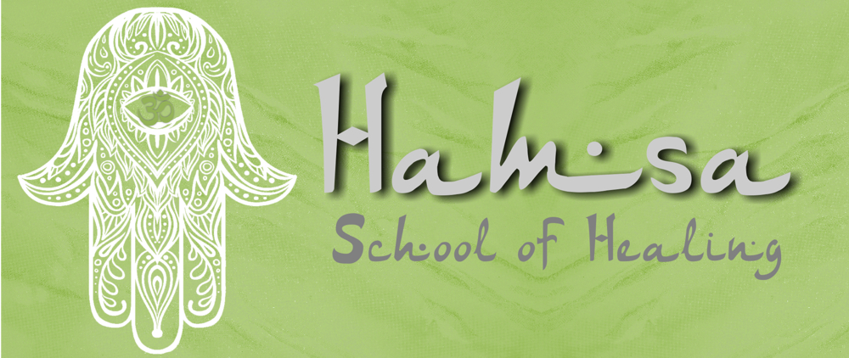
​

How to Create a Shamanic Fire Ceremony
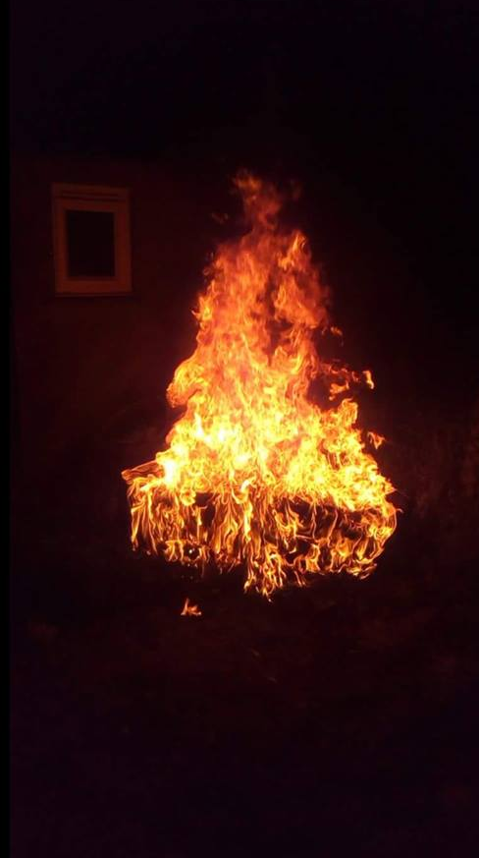
Fire allows for rapid transformation. It provides the avenue to let go of the old story and drama, to transform, to renew and to be reborn. Through fire ceremony, you honor your lessons and old belief structures by placing them in the fire and turning them over to Spirit. By releasing these old patterns and beliefs into the fire, you heal deeply at the level of the soul without having to experience them at the literal and physical levels.
Fire ceremony, one of the core ceremonies in many medicine traditions, is typically held around the full or new moon of each month when the veils between the worlds are the thinnest. In the past, when fire ceremony was taught, it was only done with a teacher for years and years before ever doing it alone. Now, shamans say that the earth and our civilization are in such great peril that fire ceremony should be held by anyone who is willing to step in. The fire itself will become your teacher and will let you know immediately if your intention is pure.
The steps to the ceremony are simple, it is only important to remember that you are creating ceremony:
Before coming to the fire circle, create an offering out of burnable materials, typically a small stick. This “spirit arrow” can represent an issue or something that needs to be honored in order for you to let go of it. The offering serves to focus one’s attention in active meditation. The object can be decorated or left as is.
- Connect with what you are honoring, the gifts you have received, or what you are envisioning into being. Using your breath, blow this intention or prayer into the offering several times.
- Ideally, you would want to do your fire out-of-doors if possible. Though fire can be done indoors, even with a candle, creating the ceremony outdoors allows you to connect deeply to the earth, the star energies and the timelessness of the location where you are holding the fire. When you are first learning, it is recommended to hold fires at night. The darkness will help you notice subtle changes and learn from the fire.
To prepare the fire:
- Place kindling in the form of a Southern Cross and then build a short teepee of wood over it. Fill in with paper and kindling as needed. Remember, this is a small ceremonial fire, not a large bonfire. (For many years I would even use pie sized aluminum pans to build my fires).
- Sacred space should be called in and then the fire can be lit. As the fire burns there is a beautiful chant thatyou can use to keep you centered and to occupy the mind. The chant calls upon the spirit of the waters beneath the earth to take your offering to Spirit. Here is the chant.
Nitche Tai Tai, N-U-Y
Oro Nika Oro Nika
Hey Hey…Hey Hey
Ooo Ai.
The following is not a literal translation, but expresses the chants essence:
O Great Mother, Mother of the Waters
We call on you, waters of our birth
Waters of our sustenance
Waters that cleanse us on our death
Waters of life.
The fire should then be “made friendly” with three offerings of olive oil (you could also use sage or tobacco):
- The first offering honors the four directions and after your honoring, olive oil is sprinkled on the fire. The fire should be allowed to burn until you sense it is time for the second offering.
- The intention of the second offering is to honor the heavens and earth and again after olive oil is sprinkled, allow the fire to burn for some time.
- For the third and last offering, connect the circle around the fire by honoring “all” those present. This may include the spirits of the land or ancient energetic beings you may sense, but not see.
With the addition of these offerings, the fire will become “friendly”, change color and burn in a different manner. You will notice this change through discovery, practice, direct observation and experience.
- When the fire is friendly, approach the fire and silently put your offering into it. The fire will transform your offering(s) and prayers back to light, turning them over to Spirit. In the same way sunlight wraps around the stick as it grows, the offering now goes back to the light wrapped with your prayers.
- If you have someone attending the fire with you they can stand behind you to “hold the space” so all of your attention can be with the fire. If you are holding ceremony alone, invite the lineage to “stand” behind you.
- As your offering burns, put your hands briefly through the smoke and fire. Draw the energy of the fire into the three main centers of your body – into the belly, into the heart, and into the forehead. Legend and lore says if you come with pure heart and intention, the fire will not burn you. You can touch the flames lightly or go deeply into them. When you place your hand into the flame, it is not meant to be sensational or dramatic, but rather a way to focus attention and energy upon your transformation.
- One additional offering is then placed in the fire for the mother earth. It is typically called the “Pachamama” stick, or “mother earth” stick. Have each person in the circle blow their prayers for the planet into the offering before it is placed into the fire.
- Sacred space is then closed. You should stay with the fire until all the prayers are consumed. Ideally the fire is allowed to burn to embers. Water should not be placed on the fire to extinguish it, only dirt if necessary.
There is a two-week period following a fire ceremony in which “instances of opportunity” appear. These “instances” provide the opportunity to translate your intent for healing, into reality. You are advised to think of the fire ceremony not as an instantaneous magical change, but rather, an opening to heal and shift distinctive habits and patterns – to manifest a different dream. Remember to recognize this “opening” and seize the opportunity to create change – then let the universe take care of the details.
Fire ceremony allows us to source from our soul and to re-remember how we have sat around sacred fires throughout time. Any time you feel “blocked”, or are working on what you want to dream into your life fire is an incredible tool to help you change and shift. My children love to participate in fire ceremony with me. They often bring their personal “stick” offerings for what is going on in their lives. We encourage you to invite family and friends to your fire ceremony. Many Light Body graduates hold monthly fire ceremonies in their own communities. These ceremonies are often open to the general public.
At this time of tremendous change, our souls long for ceremony. As you work with fire as ceremony, you will develop your own unique rituals.
Namaste

