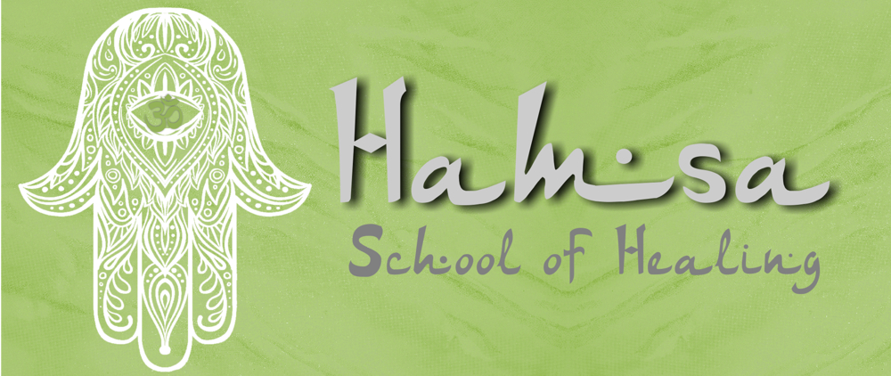
Timothy Van Minnen (Ritual Master Teacher / Energy Healer/
Psychic Medium
Cape Town South Africa / 083 431 9960 / tvanminnen@yahoo.com
https://hamsaschoolofhealing-uk.weebly.com/my-shift-in-healing.html
----------------------------------------------------------------------------------

My shift in healing.
My Healing Story by Hayden Jonas
4 months ago I had the love of my life break my heart, she walked away from us and gave up on us and I blamed myself for it.
I went through a difficult stage and trying to cope with everything because inevitably I do still love her, even now.
She’s emotionally abused me and basically destroyed me, I needed help and I needed guidance because I was at that stage where I couldn’t go on anymore.
I’ve been to Tim before and every time we pulled cards on her energy the queen card always came up, she was my queen and he has always told me that she’s the one and that’s why I still believe in her and in us because who she is now is not who I know.
Later on when she left me I phoned Tim in tears, I was distraught. He put it simply as this was meant to happen, the universe needed this to happen so I could see her bad side so I could grow to be able to love her whole heartedly.
But as time went on it became more and more difficult for me so I went to go see Tim.
Again we pulled cards on her energy and what do you know, the queen came out. Still even now as we are apart she’s my queen. He took my energy and helped me shift it away from her to help me heal, he gave me things to focus on that will make me happy and build me as a person.
However things were getting better but social media is a dangerous thing and the things I saw from her was only pulling me down more and making me more and more depressed, so much so that I had my own mother look at me dead in the eyes and say that she doesn’t know who her own son is anymore. I had my best friend say to me he’s scared I do something stupid and he loses me as a friend because without me his lost, but what made me re-think all of this and I took Tim’s word into thought a lot because what Tim says I trust with my life. I had my two year old god son lay his hand on my scars where I inflicted pain on myself and he looked at me with with those eyes and I realised then that there is more to life that this and I deserve better.
But for me being an emotional person I struggled because she still had her hooks in me deep, and Tim always encouraged cord cutting but I was too scared until the retrograde came along.
The retrograde allowed me to go back into the person I am an allowed me to see the beauty in everything again so I decided to go back to Tim for a more in depth reading and cord cutting.
I can tell you that I was scared for that session, the questions I had lined up I wasn’t ready for the answers and especially for the cord cutting.
So here’s what happened, 4 months down the line and after all the heartache and pain the queen card appears again. It comes out that the love we have will never die but I need to let her go and I need to be happy. The answers I received where not what I expected as everything that’s happening is a front but then the scary part came, cord cutting.
I’ve done cord cutting before so I know the strength of it and that’s why I was scared by mostly because I wasn’t ready to let go but I had to, I had give my problems to the universe and trust in it that everything will be okay.
First cord cut was with her new “lover”, I don’t trust him and she lied about him to me so I don’t like him and am not fond of him but he cut the negative cords with him and I felt a small shift in my energy towards him so I realised he was only a small part in this situation.
Second cord was the one I was afraid of, I closed my eyes and pictured her standing in front of me and Tim began to cut the cords and as every second passed by I felt a shift in my heart and more importantly my soul and when it came too I felt her hug me one last time then once the last cord was cut she disappeared, it felt as though a weight has been lifted off my shoulders, the cords with her have been cut but the love stayed and that made me happy.
Now I love her but don’t talk to her or anything, I wish only happiness for her and she deserves the world and if she needs me she’s knows where I am.
But now for me as a person, I’m on a roller coaster that only goes up. Tim took a broken me and guided me to fix myself, he knew the truth and he knows the outcome. He’s made me trust in the universe more and helped me trust my soul more.
I’m not 100% okay but I’m getting there, I will still continue to see Tim and he’s the only one that understands me on this level, he understands the love I have for her but more importantly he understands my soul and he took the time out to help me whenever I needed.
Tim, thank you for what you have done for me. You’ve helped me see the beauty in everyday life and have helped me get back on track with my life. You’re and extraordinary human and you have a good heart, I am forever indebted to you. Thank you is not enough because I feel it doesn’t cover what you have done for me.
To anyone that needs guidance and reassurances for life, Tim won’t sugar coat it he’ll tell you truth and help guide you into being a better human everyday.

