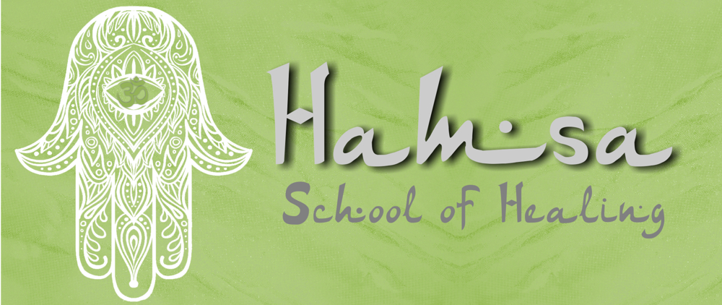

Introduction to Runes:
​Runes are an ancient form of oracle used by those seeking advice. Runes have a long history, dating back to ancient use by Germanic and Nordic tribes, and are still widely used in today’s society. Anyone can have a rune reading, but it’s also fun to be able to learn how to use them yourself. Here’s a guide to all you need to get started with using runes.
What Are Runes?
The word ‘rune’ simply means mystery, whisper or secret and it’s a form of divination or oracle reading system that’s used to help gain insight into situations or questions. Runes can be made of various materials, but are most commonly made of stone, and feature a symbol from the runic alphabet on them.
There are various different types of runic alphabets used on runes, with one of the oldest ones being the old Germanic runic alphabet known as ‘Elder Futhark’. The Elder Futhark contains 24 runes, the first six of which spell out the word ‘futhark’.
Over time this was adapted and in order to use it to write in Anglo-Saxon or Old English, a number of other runes were added to the alphabet, bringing it up to 33. This is known as the Anglo-Saxon Futhorc.
Another adaptation is the Younger, or Scandinavian, Futhark, which is believed to have been used in Scandinavia until the 17th century. All of these variations highlight changes that were made as people moved and emigrated to different countries.
As well as each rune symbol being a letter of the alphabet, they also have symbolic meanings too. Although many of these date back to traditional meanings, which would have meant a lot to the people using the runic alphabet, the intention behind the symbols still has relevance today.
For example, in the Elder Futhark:
Fehu, F, means domestic cattle or wealth.
Uruz, U, means a wild ox.
Thurisaz, T, means a thorn or a giant.
Hagalaz, H, means hail.
Ansuz, A, means an ancestral god.
Raidho, R, means wagon or chariot.
Kenaz, K, means a beacon or torch.
The Origin of Runes
The runes stem from an ancient form of Germanic alphabet, which was used by the Germanic and Nordic tribes of northern Europe, Scandinavia and Britain for writing, divination and magical purposes. Runic inscriptions have been found on stones, jewellery, weapons and objects dating back to the 3rd century AD, but it’s likely that they existed long before that.
What Can Runes Be Used For?
The runes can be used to help guide you through problems or issues and help show you what is likely to happen. They’re not a form of fortune-telling and don’t offer exact answers or give you advice - rather they offer different variables and suggest how you could behave if the event does occur. Runes are known for hinting towards answers, but leaving you to work out the details, which is where intuition is helpful.
Runic readers acknowledge that the future isn’t fixed and that individuals have the power to follow their own path and make their own decisions. So if you don’t like the guidance that a rune reading provides, you’ve got the power to change your direction, or your path, and follow a different route.
Runes can be used in many different situations. For example, one of the occasions when it can be useful to consult the runes is if you’re in a situation where you have limited information, or can only see an incomplete picture.
How Do Runes Work?
When you cast the runes, it’s not fortune-telling. The idea behind the way that runes work is that, as you ask a question or think about an issue, your conscious and unconscious minds are focused. When the runes are cast in front of you, they’re not totally random, but are choices that have been made by your subconscious.
What Can I Ask The Runes About?
Some people using runes believe you should only ask about issues, whereas others regard it as fine to ask questions. Whichever method you use, keep your question or issue clearly in your mind as you cast your runes.
Remember that’s doing a rune reading is not about seeing the future or definitive answers. It’s about looking for possible causes and effects and seeing potential outcomes.
What Sort of Runes Do I Need?
Runes can be made of different materials, including wood, stone, pebbles, crystals, bone or even metal. When you’re first starting out and discovering if you like rune casting, then a simple set will be sufficient.
However, once you’ve practiced for a while and developed a passion for runes, then it’s lovely to be able to choose and buy a special set. If you’re drawn to a certain crystal, such as rose quartz or amethyst, then perhaps investing in a crystal set of runes would be appropriate. Or you can buy a set carved into simplistic pebbles or small pieces of stone.
Either way, the material the runes are made of is a very personal choice and it’s what you do with them that really matters.
When you buy a set of runes, they will often come with an instruction booklet that explains what each rune is, what its symbol represents and how it can be interpreted.
Storing Your Runes
Runes are often stored in a little drawstring pouch, to keep them clean and together – you don’t want to accidentally lose a rune or two. Rune pouches to store your runes in are widely available, or you could find a small box to keep them in.
Using a Rune Cloth
A rune cloth is a piece of fabric that is used to put the runes on when reading them. Ideally, it should be a small white cloth and specially designed rune cloths of the right size are available.
When you’re trying out runes for the first time, you needn’t worry too much about investing in a special cloth, but it may be something you can explore once you’ve determined your love for the runes. The cloth prevents the runes from getting dirty or damaged and acts as a form of boundary for the rune casting.
How Easy Is It To Interpret Runes?
Like any form of divination or oracle reading, it can take time to master the art of reading the runes. There are books and guides available to help you understand the runic meanings and their significance in your life, and to the questions and issues you’re exploring, and with practice it does get easier. Ideally, you should receive an easy-to-understand guide to the meanings of the symbols when you purchase a set of runes.
It does help if you’re open and willing to use your intuition to assess what the stones are revealing. Don’t worry if you’re not sure at first, as this is perfectly normal. Just try and preserve, write down details of any runes you’re unsure of and see if the meanings present themselves to you over time.
When a rune appears upside down on your rune cloth, or on a table, then there alternative reverse definitions; your rune guide will provide details of this.
Even experienced rune readers, for example, say that meanings or significances they’re unsure about or stuck on can suddenly come to them at a later date.
Blank Runes
Some rune sets come with a blank rune. However, opinions over the validity of blank runes are mixed, with the traditionalists saying that there’s no historical evidence that blank runes were ever used.
It’s up to you how you want to proceed with blank runes. If you want to include them in your oracle reading, then that’s fine. But if not, you can always remove any blank runes that are included in your set.
How to Get Started With Using Runes
Find a quiet place to do your reading and start by having a period of quiet, where you clear your mind and focus on the reading you’re about to do. Think about the issue or question you have in mind and, if you so desire, you can say a prayer or call upon higher spirits to guide you with your reading.
Your rune cloth should be spread on the table in front of you, ready for the runes to lay upon it.
There are various different types of rune castings you can do – which are similar in idea to tarot layouts – but on your very first attempt, you might just like to start by picking out between one rune and analysing its significance.
This is also quite a useful method to use if you’re feeling unsure or uncertain – picking out one single rune can give you something to focus on.
Once you feel happy to progress, then have a go at some of the rune layouts and casts.
The Three Rune Layout
The three rune layout is a simple cast that’s ideal for beginners. With this cast, you should randomly select three runes from your rune bag and place them on the table in front of you.
Rune one should be on the right, rune two in the middle and rune three on the left hand side (so they should be in the order 3, 2, 1).
Rune 1 represents the overview, or your situation or query.
Rune 2, in the middle, represents a challenge.
Rune 3 represents a possible course of action that could be taken.
The Five Rune Layout
With the five rune cast, or five rune layout, the aim is to select five runes, one at a time, and lay them down on the cloth in specific places.
The first rune should go in the middle, with the subsequent runes forming a cross shape around it. Rune two should go on the left of the centre (west), rune three on the top (north), rune four at the bottom (south) and rune five to the right (east). You can either lay them face down and turn them over as you read them, or put them face up straightway.
The idea of this layout is that three runes in a horizontal position (rune 2, 1 and 5) represent your past, present and future. The rune below the central rune (4) shows what elements of the problem or issue need to be accepted, whilst the rune to the right of the centre (3) shows what help you could receive in relation to your problem or issue.
The Nine Rune Cast
In Norse mythology, nine is a magical number, so it’s appropriate to have a nine rune cast. This cast is best used if you’re trying to determine where you are in your spiritual path and what the next stages or opportunities could be and it’s a cast where you can really put your intuition to good use.
When you’re trying this casting method, you need to think about your spiritual yearnings, randomly pick nine runes out of your rune bag and hold them for a moment or two. Then scatter them onto your rune cloth.
It’s generally regarded that the runes nearer the centre relate most to the current situation, whereas those lying on the edges are less important. If runes are close together or touching each other, then they may be complementing influences, whereas runes that are on opposite sides of the cloth represent opposing influences.
Your attention should first go to the runes that have landed face up – it may help to note these down, so you can refer to them and study them in detail later. Then turn around the ones that landed upside down and read them, keeping them in their same position. These latter runes are believed to represent outside or future influences and could highlight potential new possibilities.
When you’re interpreting the runes and what they might mean, make good use of your intuition. This is one ruin casting where there aren’t hard and fast rules and it’s very much down to your own interpretation.

